THE FULL TITLE OF THE ARTICLE IS WRITTEN HERE IN CAPITAL LETTERS
Firstname Middlename Lastname
Affiliation (organization) name, city, country
author1@example.com
ORCID: https://orcid.org/0000-0000-0000-0001

Firstname Middlename Lastname
Affiliation (organization) name, city, country
author2@example.com
ORCID: https://orcid.org/0000-0000-0000-0002

Scientific adviser: Firstname Middlename Lastname, PhD, Associate Professor, Organization name
Abstract: [Abstract in the language of the article — 150–200 words: aim, methods, key results, conclusions. Delete this hint and write your own text.]
Keywords: [5–10 keywords, comma-separated, in one paragraph.]

⚠ IMPORTANT! READ THIS BOX, THEN DELETE IT COMPLETELY
1. Every element goes on its OWN line: author name — one line, affiliation — next line, e-mail — next line, ORCID — next line. Never combine them on one line.
2. The name line contains ONLY the name: degrees, titles, “student”, “master’s student” belong on the affiliation line. Do not put * or any other mark next to the name — the first author is treated as the corresponding author.
3. No second author — delete their 4 lines; a third author — add a block in the same order (name, affiliation, e-mail, ORCID). An ORCID iD is REQUIRED for every author, written as a full link (free at orcid.org).
4. The scientific adviser goes on ONE line only, starting with “Scientific adviser:” — name first, then degree/position and organization after a comma. No adviser — delete the line.
5. Do not change the Abstract and Keywords labels — the system reads them automatically. The head of the article contains only the article-language metadata.
6. Translations of the title, abstract and keywords into OTHER languages go only in the “IN OTHER LANGUAGES” section at the END of the article, using the labels shown there (Название, Аннотация, Ключевые слова) — they are published in the same form. Do not move them to the head of the article.
7. Do not use tables, text boxes or images in the header area (title, authors, abstract).
8. Tables — real Word tables only (not images), caption ABOVE the table. Figures — at least 300 dpi, caption BELOW the figure. Equations — typed in Word’s equation editor (Insert → Equation), never pasted as images. Samples are shown below.
9. Length — at least 5 pages; abstract — 150–200 words; 5–10 keywords; font Cambria or Times New Roman 12 pt; line spacing 1.15; originality — at least 70%.

INTRODUCTION
[Relevance of the topic, problem statement, aims and objectives. The literature review goes here or in the next section. In-text citations in square brackets: [1], [2].]
MATERIALS AND METHODS
[Research materials, sample, methods used and their justification.]
RESULTS
[Presentation of the results. Every table, equation and figure must be referenced in the text. Below are SAMPLES of all three elements — replace them with your own data or delete what you do not need.]
The performance indicators of the groups are presented in Table 1.
Table 1. Performance indicators by group (%)
Year | Experimental group | Control group
2022 | 38 | 30
2023 | 52 | 36
2024 | 64 | 41
2025 | 83 | 47
The efficiency gain is calculated using equation (1):
$S = \frac{n_{1} − n_{0}}{n_{0}} × 100\%$ (1)
where n₁ is the current-period value and n₀ is the base-period value.
The dynamics of the indicators are shown in Figure 1.
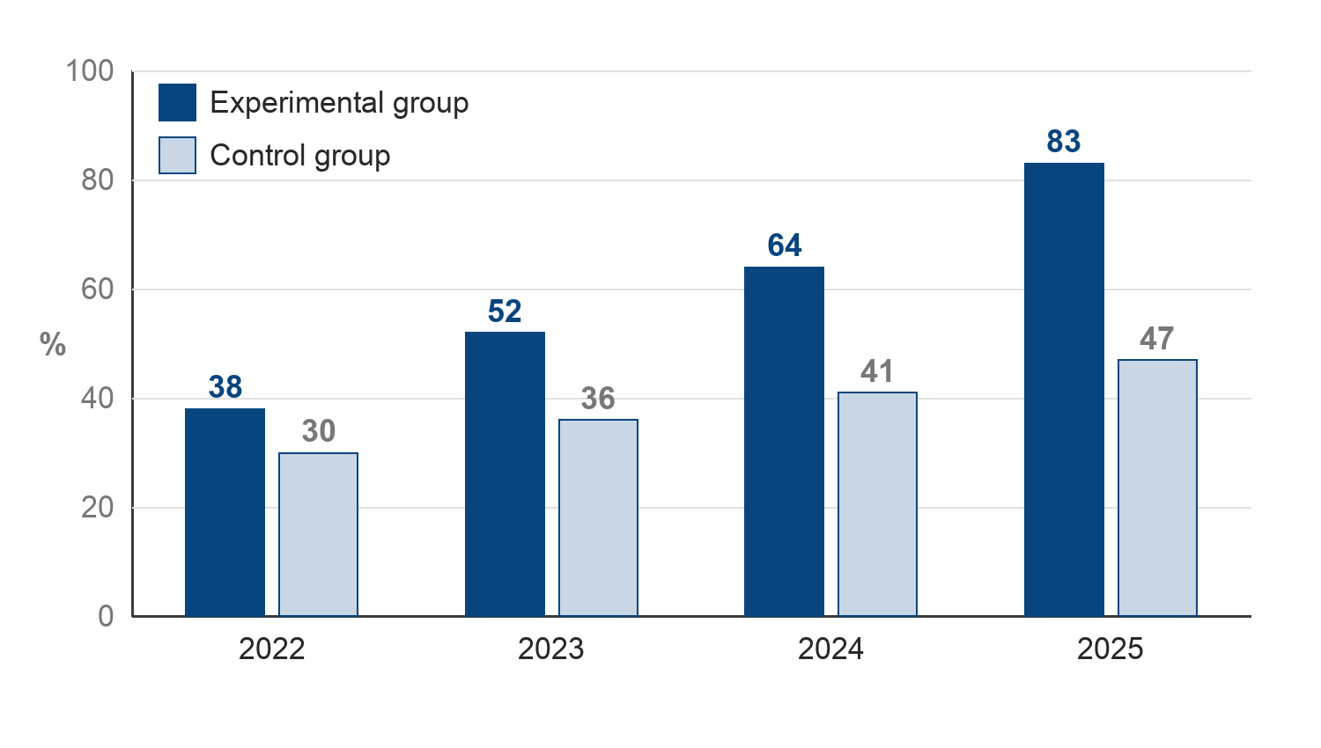
Figure 1. Dynamics of group performance (2022–2025)
DISCUSSION
[Interpretation of the results, comparison with other studies, open problems.]
CONCLUSION
[Final conclusions, proposals and recommendations.]
[APA style, numbered in citation order [number]. Sources in Cyrillic or Uzbek script are supplemented with an English translation in square brackets — see sample 2.]
REFERENCES
1. Karimov, A. A. (2021). Raqamli iqtisodiyot asoslari [Fundamentals of the digital economy]. Iqtisodiyot nashriyoti.
2. Иванов, П. П. (2019). Цифровая трансформация образования [Digital transformation of education]. Вестник науки, 12(3), 45–52.
3. Kholikova, N. (2020). Poetic features of Uzbek poetry of the national awakening period. ISJ Theoretical & Applied Science, 04(84), 615–623. https://doi.org/10.15863/TAS.2020.04.84.110

ARTICLE INFORMATION IN OTHER LANGUAGES
[This section stays at the END of the article and is published in the same form. Do not change the labels (Название, Аннотация, Ключевые слова) — the system reads them automatically. Fill in the values and delete the bracketed hints.]
Название: [НАЗВАНИЕ СТАТЬИ НА РУССКОМ ЯЗЫКЕ]
Аннотация: [Та же аннотация на русском языке, 150–200 слов. Если не можете предоставить — обратитесь в редакцию.]
Ключевые слова: [5–10 ключевых слов на русском, через запятую.]

